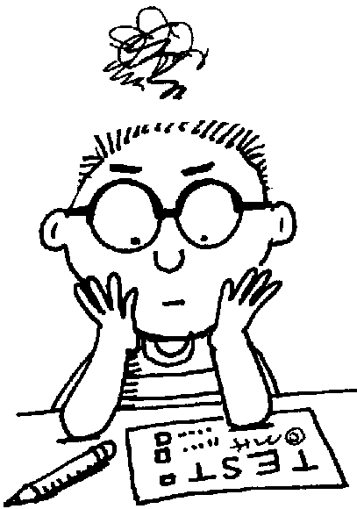**How Did I Do?**

icon175x175icon175x175

How well did you do on the Chapter 1 Test? How well did you do relative to your classmates?

Here are the results of a random sample of 20 of the Chapter 1 Tests, along with a dotplot and summary statistics.

|  |  |  |  |  |  |  |  |  |  |  |  |  |  |  |  |  |  |  |  |  |
| --- | --- | --- | --- | --- | --- | --- | --- | --- | --- | --- | --- | --- | --- | --- | --- | --- | --- | --- | --- | --- |
| Test Scores | 61 | 65 | 65 | 73 | 75 | 77 | 78 | 78 | 79 | 80 | 80 | 80 | 80 | 81 | 81 | 88 | 89 | 93 | 98 | 99 |

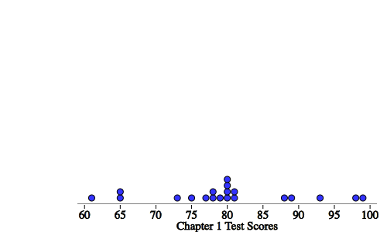

|  |  |  |  |  |  |  |  |
| --- | --- | --- | --- | --- | --- | --- | --- |
| **n** | **mean** | **SD** | **min** | **Q1** | **med** | **Q3** | **max** |
| 20 | 80 | 10 | 61 | 76 | 80 | 84.5 | 99 |

1. Biff scored a 65. What is Biff’s percentile?

2. Was Biff above or below the mean? By how many points? By how many standard deviations?

3. Marty scored an 88. What is Marty’s percentile?

4. Was Marty above or below the mean? By how many points? By how many standard deviations?

**A *z*-score is defined as the number of standard deviations above or below the mean.**

5. Write a formula for calculating a z-score. 

6. Goldie scored a 98 on the Chapter 1 Test. Find and interpret the z-score.

Bonus: Goldie was aspiring for what job?

7. There are two mathematical operations used when calculating a z-score:

a. First, we take each score, and ____________________ the mean (remember the mean was 80). Fill in the table and then make a dotplot for each.

|  |  |  |  |  |  |  |  |  |  |  |  |  |  |  |  |  |  |  |  |  |
| --- | --- | --- | --- | --- | --- | --- | --- | --- | --- | --- | --- | --- | --- | --- | --- | --- | --- | --- | --- | --- |
| SCORE | 61 | 65 | 65 | 73 | 75 | 77 | 78 | 78 | 79 | 80 | 80 | 80 | 80 | 81 | 81 | 88 | 89 | 93 | 98 | 99 |
| SCORE - MEAN |  |  |  |  |  |  |  |  |  |  |  |  |  |  |  |  |  |  |  |  |

Dotplot for SCORE Dotplot for SCORE - MEAN



What happens to the shape, center, and variability when you subtract the mean from each score?

b. Second, we take the SCORE – MEAN and ____________________by the standard deviation (remember the standard deviation is 10). Fill in the table and then make a dotplot for each.

|  |  |  |  |  |  |  |  |  |  |  |  |  |  |  |  |  |  |  |  |  |
| --- | --- | --- | --- | --- | --- | --- | --- | --- | --- | --- | --- | --- | --- | --- | --- | --- | --- | --- | --- | --- |
| SCORE - MEAN | -19 | -15 | -15 | -7 | -5 | -3 | -2 | -2 | -1 | 0 | 0 | 0 | 0 | 1 | 1 | 8 | 9 | 13 | 18 | 19 |
| SCORE – MEAN  SD |  |  |  |  |  |  |  |  |  |  |  |  |  |  |  |  |  |  |  |  |

Dotplot for 

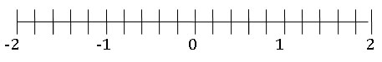

What happens to the shape, center, and variability when you divide by the standard deviation for each value?

8. Summarize: What happens to the shape, center and variability of a distribution when you

**…add or subtract the same value *a*** from each value?

**…multiply or divide by the same value *b*** from each value?

1. What is the mean and standard deviation of the distribution of z-scores? Will this be true for any distribution of z-scores? Explain.

Describing Location in a Distribution

Important Ideas:

Check Your Understanding:

1. A screenshot of a cell phone

   Description automatically generatedAccording to an article on Yahoo!news, you should change your sheets every 7 days…at minimum. To investigate the sheet changing habits of adults, a random sample of 20 adults reported how often they change their sheets using an anonymous survey. Here is a dotplot and summary statistics of the results.

1. Suppose you convert the time before changing sheets from days to weeks. Describe the shape, mean, and standard deviation of the distribution of time before changing sheets in weeks.
2. The adults in the study are given an article explaining the health benefits that would arise from changing their sheets more often. After reading the article each person agrees to change their sheets one week sooner than they used to. How does the shape, center, and variability of this distribution compare with the distribution of time in part (a)?
3. Now suppose you convert the time before changing sheets from part (b) to *z*-scores. What would be the shape, mean, and standard deviation of this distribution? Explain your answers.