How good are the predictions for Barbie?
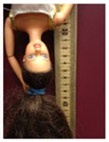
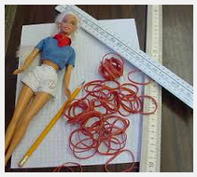

Here is the data from one of the groups. The group forgot to record their measurement for 5 rubber bands.

Number of rubber bands | 0 | 1 | 2 | 3 | 4 | 5 | 6 | 7
Distance traveled (cm) | 25 | 32 | 41 | 49 | 55 | ? | 69 | 78

- Go to stapplet.com to make a scatterplot. Then click “Calculate least-squares regression line”. This is the line that best models the data. Write the equation below.

- Use the regression line to predict the distance Barbie travels for 5 rubber bands. Show work.

- One of the group members later found the measurement for 5 rubber bands was 64 cm. Was the prediction from #2 too high or too low? How far off?

- Predict the distance that Barbie would travel if the group used 20 rubber bands. Would you trust this prediction more or less than the prediction you made in #2?

- What is the y-intercept of the equation of the regression line? What does it mean?

- What is the slope of the equation of the regression line? What does it mean?

Prediction, Residuals, Interpreting a Regression Line
Important Ideas:

Check Your Understanding:

Michael is a runner. He uses his Apple watch to keep track of his distance and the number of calories he burns for 20 runs. A scatterplot of y = calories burned and x = distance (in miles) shows a fairly strong, positive linear relationship. The regression equation $\hat{y}=20+160x$ models the data fairly well.

- Interpret the slope of the regression line.

- Does the value of the y intercept have meaning in this context? If so, interpret the y intercept. If not, explain why.

- Predict the number of calories Michael burns if he runs 5 miles.

- Calculate and interpret the residual if his Apple watch said that he burned 910 calories on a 5-mile run.

- Michael is thinking about signing up for his first marathon. So far, his longest run has only been 10 miles. Should he use the regression equation to predict how many calories he would burn if he runs a marathon (26.2 miles)? Explain.

