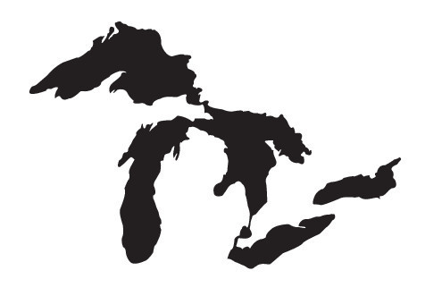
How much of the Earth is covered by water?
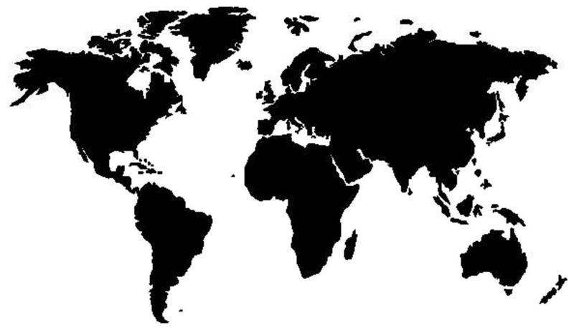

What proportion of the Earth is covered by water? We will investigate this question by taking a random sample of locations on the globe.

- How many locations did your class sample? ______ How many locations were water? ______

- Calculate the proportion of locations from your sample that are water. _______

3. Construct a 95% confidence interval to estimate the proportion of the Earth that is water.

STATE: State the parameter you want to estimate and the confidence level.

Parameter: _____________________________________ Confidence level: _____

PLAN: Identify the appropriate inference method and check conditions.

Name of procedure:

Check conditions:

DO: If the conditions are met, perform the calculations.

General Formula for any confidence interval:

Specific Formula for this confidence interval:

Plug numbers into the formula:

Answer:

CONCLUDE: Interpret your interval in the context of the problem.

Interpret:

Estimating a Population Proportion: The 4-Step Process
Important ideas:

Check Your Understanding
A community activist group in Austin, Texas wanted a particular issue to be placed on the ballot of the upcoming election. To make it on the ballot, 20,000 valid signatures were needed. The group turned in their petition with 24,598 signatures. To pass the validity test 20,000/24,598 = 81.3% of the signatures must be valid. It is too time consuming to check all of the signatures, so a random sample of signatures are checked. The individual checking the signatures needs to be 95% confident that the true proportion of valid signatures are estimated with, at most, a 2% margin of error.

- Using a conservative estimate for $\hat{p}$, how large of a sample is needed?

- In the activist group’s previous petition, 85% of the signatures were valid. Using this value as a guess for $\hat{p}$, find the sample size needed for a margin of error of at most 2 percentage points with 95% confidence. How does this compare with the required sample size from Question 1?

- What if the company president demands 99% confidence instead of 95% confidence? Would this require a smaller or larger sample size, assuming everything else remains the same? Explain your answer.

