Can we predict a person’s height from their shoe? Part 2.
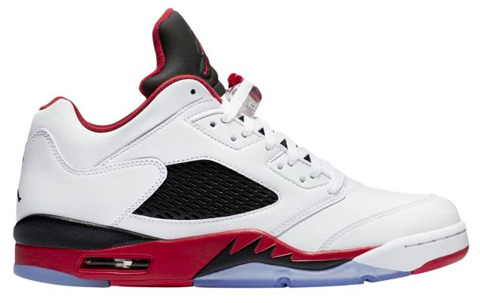
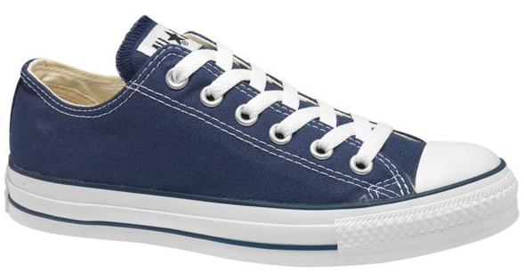
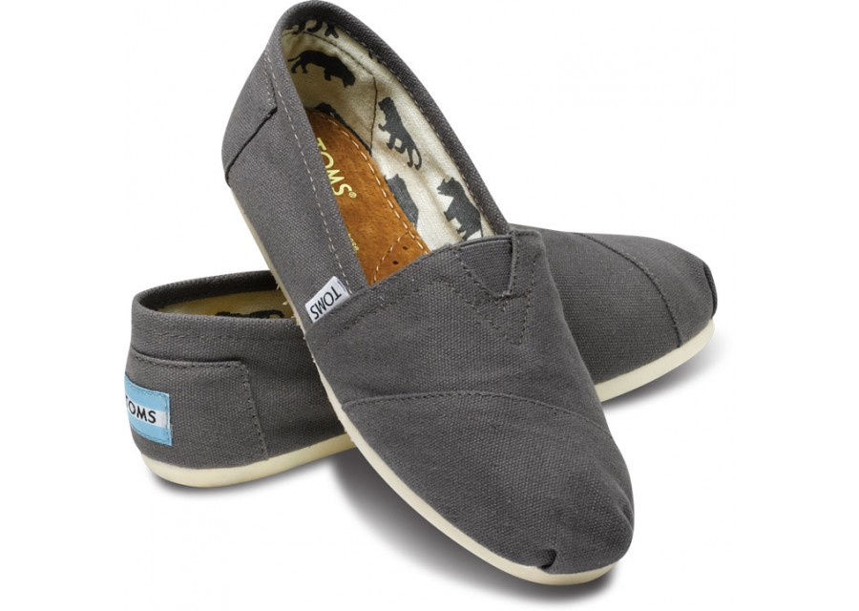

Could we use the length of a person’s shoe to accurately predict their height?

Here is the class data from a small class of 10 students.

Shoe (cm) | 29 | 25 | 22 | 30 | 33 | 21 | 23 | 26 | 31 | 19
Height (cm) | 183 | 174 | 170 | 185 | 190 | 163 | 170 | 179 | 190 | 164

- What is the line of best fit for the data?______________________________________

- What is the slope of the line of best fit?________. What does this slope mean in the context of the problem?

- What is the y-intercept of the line of best fit?________. What does this y-intercept mean in the context of the problem?

- Use the line of best fit to predict the height of a person with a shoe size of 26 cm. Show work.

- What was the actual height of the student in class with a shoe size of 26 cm?

- How far off was our prediction from #4? Too high or too low?

