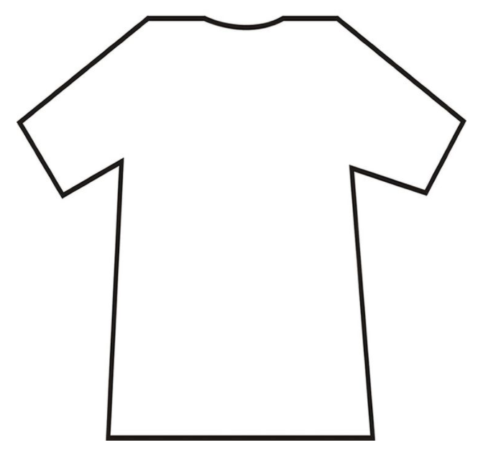

Yes Parkinson’s Yes Parkinson’s

Yes Parkinson’s Yes Parkinson’s

Yes Parkinson’s Yes Parkinson’s

No Parkinson’s No Parkinson’s

No Parkinson’s No Parkinson’s

No Parkinson’s No Parkinson’s

