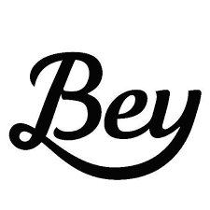
Does Beyoncé write her own lyrics?
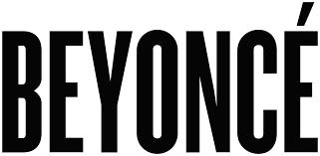

- Quickly circle a random sample of 5 words. Write them below. How many letters in each word?

- What is the average word length of your sample? ________.

- Put your average on the dotplot on the white board at the front of the room. Copy the class dotplot below.

- Find a new sample of 5 words using a random number generator. Put your average on the dotplot on the white board at the front of the room. Copy the class dotplot below.

- How is the dotplot from #4 different than the dotplot for #3? Which do you think is a better estimator of the true mean word length?

- What do you think the true mean word length is for “Crazy in Love”?

- It is known that Beyonce wrote the lyrics for all of the Destiny’s child songs. The average word length for these songs is 3.64 letters. Based on your samples, do you have good evidence that Beyonce did not write the lyrics for “Crazy in Love”. Explain.

Sampling Methods
Important ideas:

Check Your Understanding
- A sign at a local business says, “Rate us with 5-stars on Google and get a $10 gift card!” The store manager reads the ratings to learn how people in the community feel about the business.
- What type of sample did the manager obtain?
- Explain why this sampling method is biased.

- The manager finds that 92% of customers rate the business with 5 stars. Is 92% likely to be greater than or less than the percentage of all people in the community who truly believe the business deserves 5-stars?

- To help reduce bias, the manager decides to survey the next 10 customers that make a purchase.
- What type of sample did the manager obtain?
- Explain why this sampling method is biased.

- How could the manager avoid the bias described in Question 2?

