**Do we have Normal test scores?**

Here are the Chapter 1 Test scores for 80 of the current AP Statistics students



Is the distribution of Chapter 1 Test scores approximately normal? Justify your answer using several different approaches. The group with the most convincing argument will win a prize.

Density Curves and Normal Distributions

Important Ideas:

Check Your Understanding:

The following figure is a Normal probability plot of the difference between the desired thickness of a cell phone screen protector and the actual thickness of the cell phone screen protector for a random sample of 300 screen protectors, in micrometers. Use the graph to determine if this distribution of difference in thickness is approximately Normal.

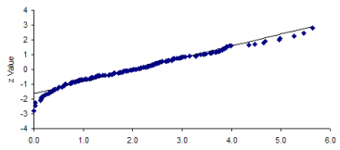

Difference in thickness (micrometers)