How many iPhones will be sold?

Here is the data of all iPhone sales during their opening weekends:
iPhone | Year  (after 2000) | Units Sold (millions)
Original | 7 | 0.5
3G | 8 | 1
3Gs | 9 | 1
4 | 10 | 1.7
4S | 11 | 4
5 | 12 | 5
5C, 5S | 13 | 9
6, 6 Plus | 14 | 10
6S, 6S Plus | 15 | 13

- Use stapplet.com to create a scatterplot of the data with year as the explanatory variable and units sold as the response. Sketch the scatterplot in the space above.

- Would you use a linear regression to model the data? Sketch the residual plot below to support your explanation.

- Since we expect that the data is nonlinear, we cannot make a linear regression. However, we can transform the data to make it more linear. First we need to decide what type of function we think the data would best fit so that we can transform it.

- What type of model do you think best fits the data?

- What is the general form of this model?

- Algebraically, what is the inverse of that function?

- How can we transform our data using this inverse?

- Complete the table below.
Year | Actual Units Sold (millions) | log(Units Sold (millions)
7 | 0.5
8 | 1
9 | 1
10 | 1.7
11 | 4
12 | 5
13 | 9
14 | 10
15 | 13

- Use stapplet.com to create a scatterplot of the data with year as the explanatory variable and log(units sold) as the response. Sketch the scatterplot in the space above.

- Calculate the LRSL for the transformed data and write it below.

- Do you think the regression line is a good fit for the transformed data? Why or why not? Explain using the residual plot and sketch it below.

- According to this model, how many iPhones should be sold in 2015?

- Calculate and interpret the residual for the actual number of iPhones sold in 2015.

Transforming Nonlinear Data
Important Ideas:
Check Your Understanding:
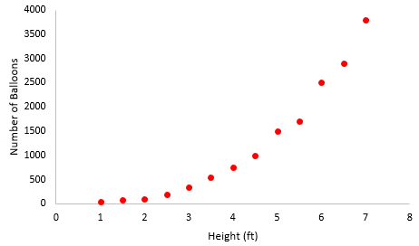
A party company specializes in creating balloon rooms, which are rooms that are filled with balloons from floor to whatever height is desired. The number of balloons needed to create a balloon room is a function of the length and width of the room as well as the desired height. Here is a scatterplot showing the number of balloons needed to fill rooms that have a similar amounts of floor space to various heights. Note the clear curved form.

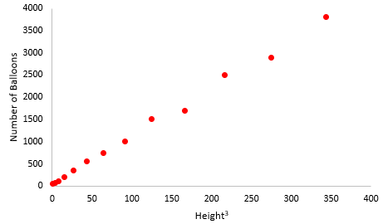
Because height is one-dimensional and number of balloons to fill the room (volume) is three-dimensional, a power model of the form number of balloons = a(height)³, should describe the relationship. Here is a scatterplot of number of balloons versus height³. Because the transformation made the association roughly linear, we used computer software to perform a linear regression analysis of y = number of balloons versus x = height³.
Regression Analysis
Predictor | Coef | SE Coef | T | P
Constant | 45.008 | 29.87 | 1.507 | 0.15
Height^3 | 10.809 | 0.197 | 54.818 | 0.000
S = 76.938 | R-Sq = 99.6% |  | R-Sq(adj) = 99.5%

a. Give the equation of the least-squares regression line. Define any variables you use.

b. Suppose you want to fill a room of similar floor size to a height of 8 feet. Use the model from part (a) to predict the number of balloons that would be needed.

