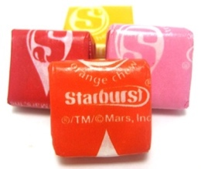
Matching Starbursts With a Twist
Same game, but one simple rule change. This time after you choose the first Starburst from the bag, you will NOT replace it into the bag before choosing the second Starburst.
What is the probability of winning this new game?
1. Do you think the probability of winning while playing without replacement will be greater than or less than the probability of winning when playing with replacement? Explain.

2. Your group should play the game 10 times total. Based on the results from your group, what is the probability of winning this game?

3. Let’s see what happened in the other groups. Record your number of wins at the front of the room. Based on the results from your whole class, what is the probability of winning this game?

4. Let’s try to use a Tree Diagram to calculate the theoretical probability.
Fill in the blank boxes with the correct probabilities.

2nd = P(1st Red AND 2nd Red)
1st is Red

Red

2nd = P(1st Red AND 2nd Yellow)

Yellow
Starburst Game

2nd = P(1st Yellow AND 2nd Red)

1st is Red
Yellow

2nd = P(1st Yellow AND 2nd Yellow)

Yellow

5. Find the theoretical probability of winning this game.

6. What is the probability that the 1st candy was red, given that the person won the game?

