How Much Do Fans Love Justin Timberlake? Day 1

Justin Timberlake’s concert promoter wants to find out how much fans enjoy the concerts. He will ask fans, “From 1 to 100, where 100 is the most, how much did you enjoy the concert?” The section he wants to survey has 50 seats (5 rows x 10 columns). The stage runs along the northern edge of the venue (where Justin is pictured). He wants to take a sample of 10 seats.

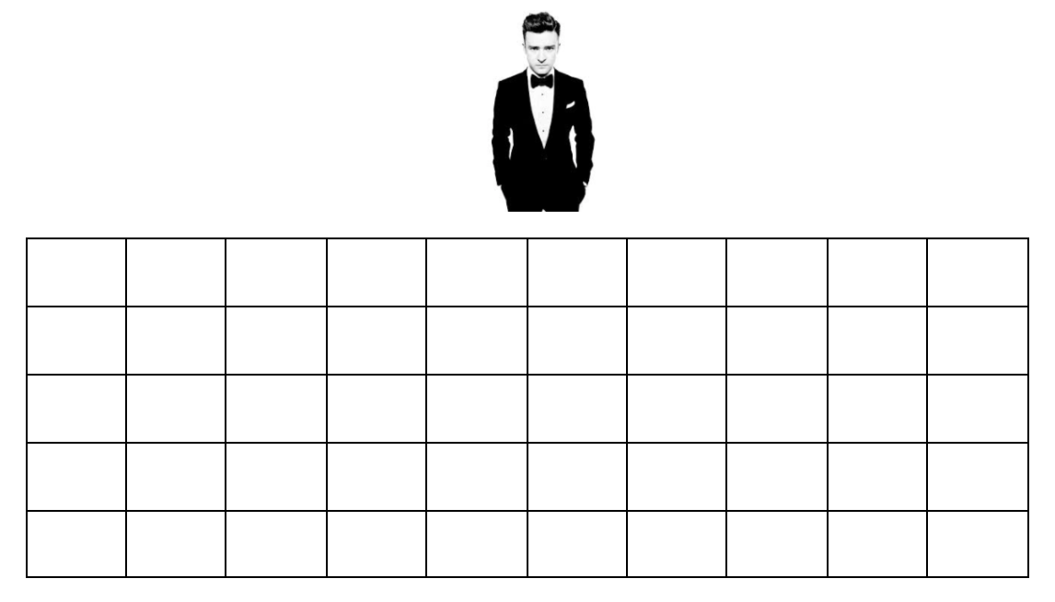
- Method #1:
Take a simple random sample (SRS) of 10
fans. Explain below the steps you used to
obtain an SRS.

- Method #2:
Randomly choose 2 fans from each
horizontal row.

- Method #3:
Randomly choose 1 fan from each
vertical column.

- Which method do you think is best? Why?

- Now, it’s time for the actual data. For each of your samples on the previous page, calculate the average enjoyment. Add your average to the dotplots on the board.
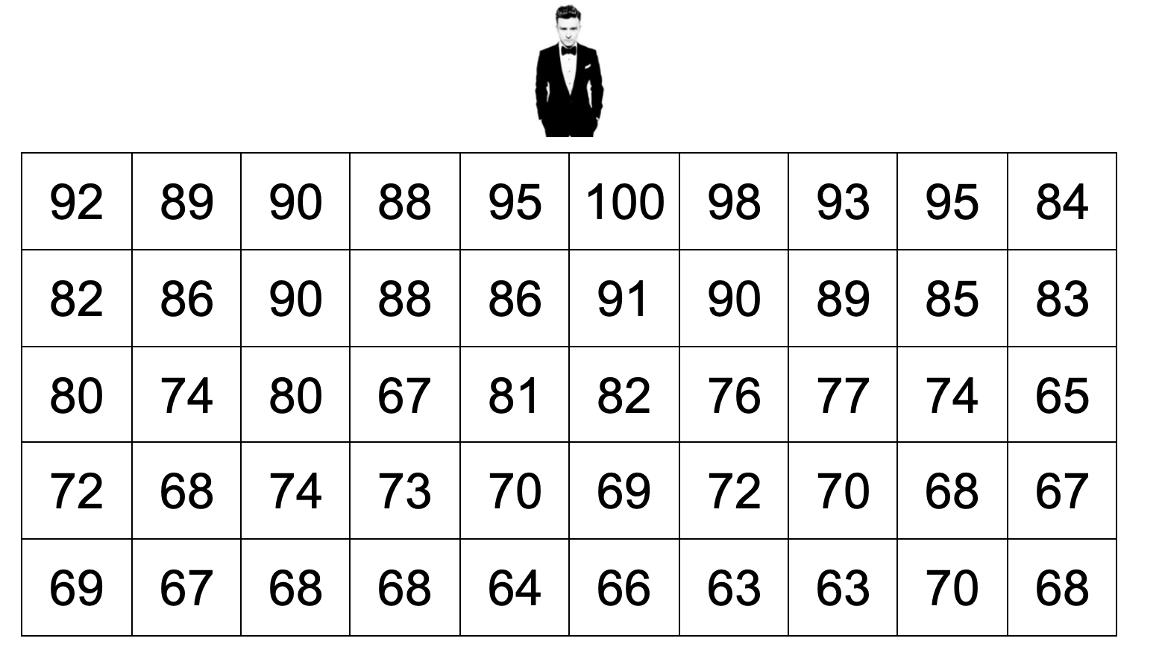

Sample #1:

Sample #2:

Sample #3:

Method #1: SRS

average enjoyment

Method #2: Stratify by Row

average enjoyment

Method #3: Stratify by Column

average enjoyment

Other Random Sampling Methods Day 1
Important Ideas:
Check Your Understanding:

To score the AP Statistics Exams ETS hires Exam Readers, Table Leaders, and Other Leadership. Each reading room consists of 16 Exam Readers and 2 Table Leaders. There are 100 reading rooms. The 18 members of Other Leadership work together in a room.

- Describe how to select a stratified random sample of 36 people hired by ETS to score the AP Statistics Exams. Explain your choice of strata.

- Describe how to select a cluster sample of 36 people hired by ETS to score the AP Statistics Exams. Explain your choice of clusters.

- Explain a benefit of using a stratified random sample and a benefit of using a cluster random sample in this context.

