 **Are you sure Mrs. Gallas isn’t a good free throw shooter?**

In our introduction to significance tests, we used simulation to estimate a P-value to decide whether or not Mrs. Gallas was exaggerating about her free throw percentage. Today, we will use a formula to find a *P*-value.

1. We’re going to carry out the significance test from lesson 9.1 again. Begin by writing the hypotheses.
2. a. Each class found a different P-value because each dotplot was different. Would it be appropriate to use a Normal distribution to model the sampling distribution of ? Justify your answer.

b. Are there any other conditions we should check?

1. Now that conditions have been met, find the mean and standard deviation of the sampling distribution of .
2. Use the mean and standard deviation you found to label the Normal curve.
3. 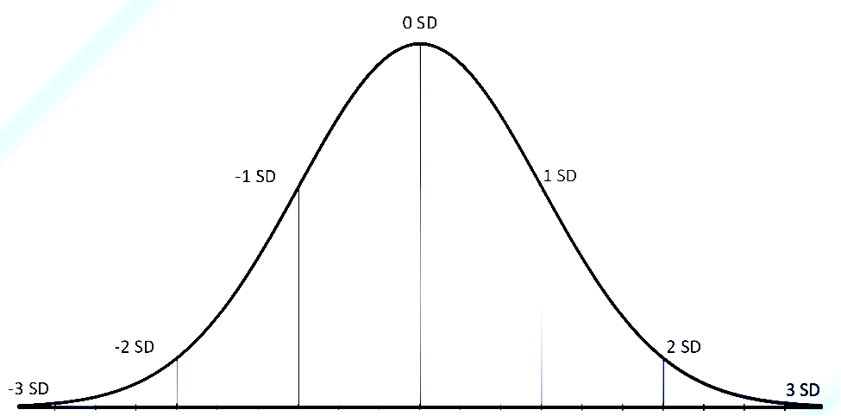How many standard deviations below the mean (*z*-score) is $\hat{p}=.64$? Label it on the normal curve.
4. Find the probability of an 80% shooter making 32/50 ($\hat{p}=.64$) or less.
5. What conclusion can we make?

Significance Test for *p*

Important ideas:

Check Your Understanding

Sharon claims that 90% of students can identify the smell of a skunk. She carries out a study to test this theory. She selects a random sample of 100 students and asks them each to take a whiff from a bag that is filled with skunk smell. She finds that 84 are able to correctly identify the smell as that of a skunk. She would like to know if these data provide convincing evidence that less than 90% of students can identify the smell of a skunk. Use *α* = 0.05.

1. State appropriate hypotheses for performing a significance test. Be sure to define the parameter of interest.
2. Explain why the sample result gives some evidence for the alternative hypothesis.
3. Check if the conditions for performing the significance test are met.
4. Calculate the standardized test statistic and *P*-value.
5. What conclusion should Sharon make?