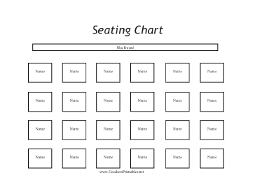
Does seat location matter – Part 2?
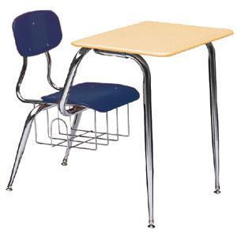

Do students who sit in the front rows do better than students who sit farther away? Mrs. Gallas took a random sample of 30 students from her classes and found these results.

Row | 1 | 1 | 1 | 1 | 1 | 1 | 2 | 2 | 2 | 2 | 2 | 2 | 3 | 3 | 3 | 3 | 3 | 3
Score | 76 | 77 | 94 | 99 | 88 | 90 | 83 | 85 | 74 | 79 | 77 | 79 | 90 | 88 | 68 | 78 | 83 | 79
Line of best fit:________________

Slope: b = SE_{b} = 1.33
Row | 4 | 4 | 4 | 4 | 4 | 4 | 5 | 5 | 5 | 5 | 5 | 5
Score | 94 | 72 | 101 | 70 | 63 | 76 | 76 | 65 | 67 | 96 | 79 | 96

1. If Mrs. Gallas were to take another random assignment of 30 students, do you think the slope of the LSRL would be the same? Why?

2. We are going to construct a 95% confidence interval for the slope of the population regression line. Identify the parameter and statistic.

Parameter:________________________________ Statistic:____________

3. There are five conditions to check.

- Linear: The scatterplot needs to show a linear relationship. Also, the residual plot doesn’t have a leftover curved pattern. Sketch each at right.

- Independent:

- Normal: A dotplot of the residuals cannot show strong skew or outliers. Make one using the applet and sketch it at right.

- Equal SD: The residual plot does not show a clear sideways Christmas tree pattern.

- Random:

4. Construct the interval:

General Formula: Specific Formula:

Work:

5. Conclude:

Confidence Intervals for Slope
Important ideas:

Check Your Understanding
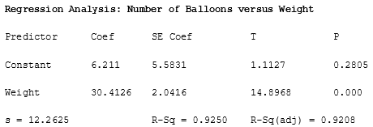
A thrill-seeker wanted to try to travel across a large field while being suspended in the air by holding onto balloons. In order to determine the number of balloons needed per pound of weight, he did a preliminary study. He selects a random sample of 20 rocks of various sizes. He weighed each one and also determined how many balloons are needed to lift the rock. Here is output from a least-squares regression analysis of the data.
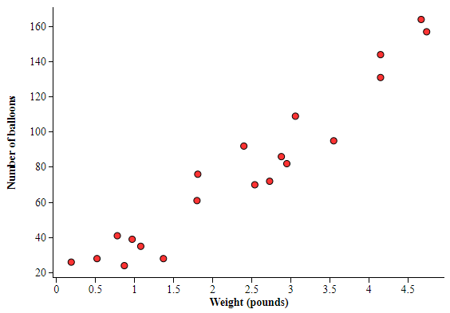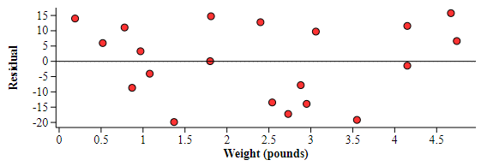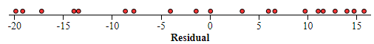

Construct and interpret a 90% confidence interval for the slope of the population regression line.

