Modified

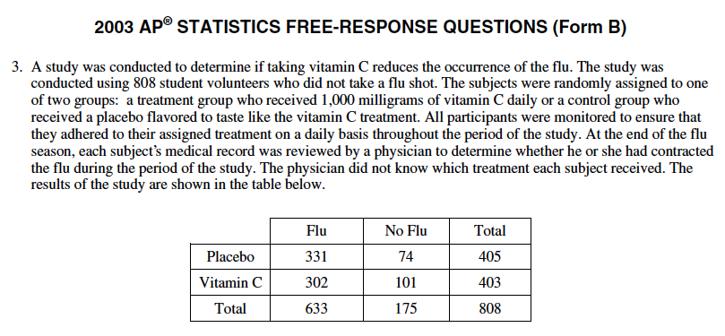

- Is this study an experiment or an observational study? Explain your answer.
- If a student volunteer is selected at random from those students in the study, what is the probability that they contracted the flu?
- Given that a student took Vitamin C, what is the probability that they contracted the flu?
- Based upon your answers in part b & c, are “contracting the flu” and “taking Vitamin C” independent of each other? Explain.
- A health expert believes that Vitamin C reduces the occurrence of the flu in the population of students who would volunteer for such a study. State the name of the significance test and the null and alternative hypothesis that the health expert could have used to assess his claim.
- Assume that the conditions for running this test are met, the test resulted in a p value= 0.0096. Based upon the p value, what conclusion should the health expert make? Explain.

