What was the real average for the Chapter 6 test?
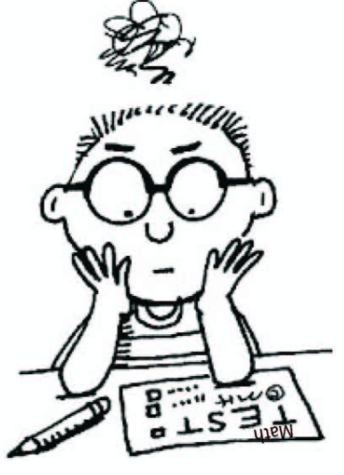

How did the Chapter 6 test go? Today, we will be taking a sample from a population. We will use the average from the sample to estimate the average for the population.

Yesterday we looked at a very small class of students as the population. In reality there were many students who took the test. Take a random sample of 5 students and record their scores. Then find the mean. Repeat this for a total of 4 times.

Scores:______________ Mean:______ Scores:______________ Mean:______
Scores:______________ Mean:______ Scores:______________ Mean:______

- Write each mean on a different sticker and put the stickers in the appropriate location on the poster at the front of the room. Copy down the dotplot that is created on the poster.

- What does each dot on the poster represent?

- What do you think the true Chapter 6 test average is?

- A sampling distribution shows the means calculated from all of the possible samples of size 5 from the population. Is the above dotplot a sampling distribution? Explain.

- We took a random sample of 5 test scores at Rockford high school and got a mean of 68. Is this convincing evidence that Rockford students did worse than students at our school or is it possible the Rockford has the same average?

What is a Sampling Distribution? Day 2
Important ideas:

Check Your Understanding
Pennies made prior to 1982 were made of 95% copper. Because of their copper content, these pennies are worth about $0.023 each. Pennies made after 1982 are only 2.5% copper. Jenna reads online that 13.2% of pennies in circulation are pre-1982 copper pennies. Jenna has a large container of pennies at home. She selects a random sample of 50 pennies from the container and finds that 11 are pre-1982 copper pennies. Does this provide convincing evidence that the proportion of pennies in her container that are pre-1982 copper pennies is greater than 0.132?
- Identify the population, parameter, sample and statistic.

Population: Parameter:

Sample: Statistic:

- Does Jenna have some evidence that more than 13.2% of her pennies are pre-1982 copper pennies?

- Provide two explanations for the evidence described in #2.

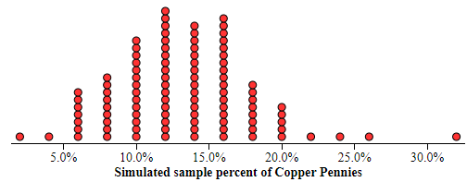
We used technology to simulate selecting 100 SRSs of size n = 50 from a population of pennies in which 13.2% are pre-1982 copper pennies. The dotplot shows $\hat{p}$ = the sample proportion of copper pennies for each of the 100 samples.

- There is one dot on the graph at 0.22 (or 22%). Explain what this dot represents.

- Assuming that 13.2% of pennies in circulation are pre-1982 copper pennies, is it surprising to randomly select 50 pennies for which $\hat{p}$ = 11/50 = 22% or greater? Justify your answer.

- Based on your previous answers, is there convincing evidence that more than 13.2% of pennies in Jenna’s container are pre-1982 copper pennies? Explain your reasoning.

