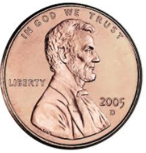
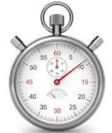
Exploring Density Curves
Complete each of the following experiments and submit your answers using the google form. Resubmit your answers for a total of 3 submissions. Predict (sketch) what the graphs of the class data from each experiment will look like if we did this many many times. Draw and label lines where you predict the mean and median will be.

Experiment 1: Roll a die and record the value it lands on. 1st roll: 2nd roll: 3rd roll:

Prediction: Actual:

Experiment 2: Try to toss a penny and make it land on the target. Measure the distance of the penny from the target in cm. Round to the nearest tenth.
1st Attempt: 2nd Attempt: 3rd Attempt:

Prediction: Actual:

Experiment 3: Try to stop your stopwatch at exactly 5 seconds. Record what the stopwatch reads below. Record to the hundredths place.
1st Attempt: 2nd Attempt: 3rd Attempt:

Prediction: Actual:

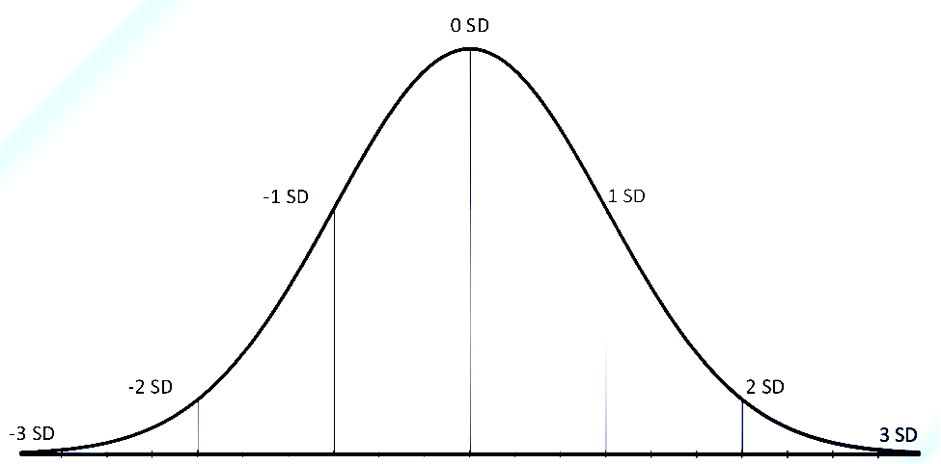
Normal Curves: Label the values 1, 2, and 3 standard deviations above and below the mean using the stopwatch data.

What percentage of the data is within two standard deviations of the mean?

What percentage of the data is further than two standard deviations from the mean?

What percentage of the data is greater than 1 standard deviation above the mean?

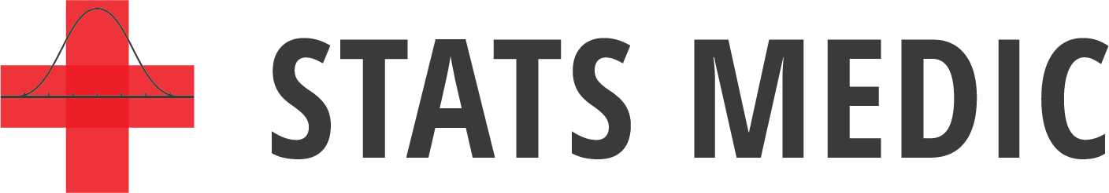
What percentage of the data is between z = –1 and z = 2?
Density Curves and Normal Distributions
Important Ideas:
Check Your Understanding:
- A game that is sometimes played at baby showers asks the guests to cut a length of yarn that they believe will best measure the distance around the mom’s baby bump. At a particular baby shower the length of string cut by the guests was uniformly distributed over the interval 40 to 50 inches.

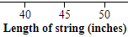
- What height must the density curve have? Justify your answer.

- About what percent of the guests cut their yarn longer than 48 inches?

- Calculate and interpret the 25th percentile of this distribution.

2. The distribution of waist circumference for women who are 8 months pregnant is approximately Normal with mean µ = 44 inches and standard deviation σ = 4 inches.

- Sketch the Normal curve that approximates the distribution of waist circumference for women who are 8 months pregnant. Label the mean and the points that are 1, 2, and 3 standard deviations from the mean.

- About what percent of women who are 8 months pregnant have a waist circumference that is less than 40 inches? Show your work.

- A waist circumference greater than 52 inches may indicate excess amniotic fluid. What percent of women who are 8 months pregnant may have excess amniotic fluid? Justify your answer.

