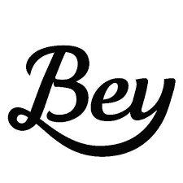
Does Beyonce write her own lyrics?

"' “Crazy in Love' was really hard to write because there was so much going on … I mean, I had written —
what? —seven, eight number one songs with Destiny's Child, in a row." Beyonce, Vanity Fair

We can use statistics to help determine whether or not Beyonce wrote the song “Crazy in Love”. If we can find the average word length from the song, we can compare it to the average word length for songs that we know for sure were written by Beyonce.

- Quickly circle a random sample of 5 words from the song. Write them below. How many letters in each word?

- What is the average word length of your sample? ________.

- Put your average on the dotplot on the white board at the front of the room. Copy the class dotplot below.

- Find a new sample of 5 words using a random number generator. Put your average on the dotplot on the white board at the front of the room. Copy the class dotplot below.

- How is the dotplot from #4 different than the dotplot for #3?

- Take a random sample of 10 words from “Crazy in Love”. Find the average of your sample and put it on the dotplot at the front of the room. Copy the dotplot below.

- What happens to the dotplot when we increase the sample size?

- It is a well known fact that Beyonce wrote the lyrics for all of the Destiny’s child songs. The average word length for these songs is 3.64 letters. Based on your samples, do you have good evidence that Beyonce did not write the lyrics for “Crazy in Love”. Explain.

