How long until the zombies take over?



On the TV show The Walking Dead, a disease was contracted that turns people into zombies or Walkers. If the Walkers bite a human, the human is turned in to a Walker. Assume that the each Walker turns one person a week into a zombie and that none of the Walkers are killed.

1. The diagram below represents a town with 140 people. Each circle represents a human; each crossed out circle represents a Walker. Keep track of the human and Walker populations over time.

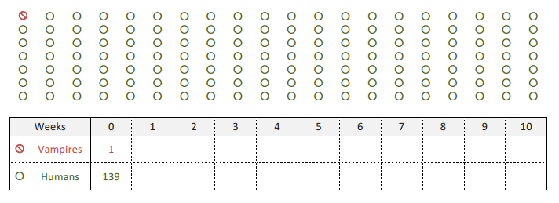

Walkers

1. How does the Walker population change each week, and how long will it take before everyone in town is a Walker?
2. Try to write a function that gives the number of Walkers as a function of the number of weeks that have passed.

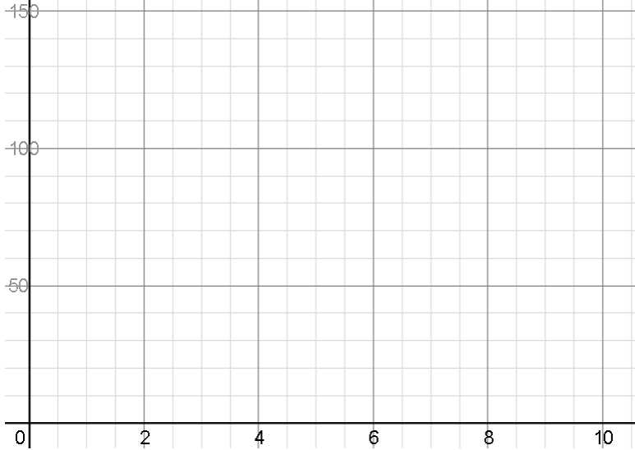

1. Graph the function:

Domain:

Range:

1. A different town of 140 started with 3 Walkers. Complete the table below.



Walkers

137

3

1. How long will it take for everyone in that town to be a Walker?
2. Write a function to describe the table. How is it different from your answer to 1b?
3. If you graphed the equation, how would the graph change from 1c?
4. In a different town of 140, the Walker is trapped for the first two weeks so it is not able to bite any humans. On week 3, it gets out. Track the population below.



Walkers

1. Write a function to describe the table. How is it different from your answer to 1b?
2. If you graphed the equation, how would the graph change from 1c?
3. During week 4, Rick comes to town. He kills 1 Walker a day. Write an equation to describe this relationship. Can he save the town?