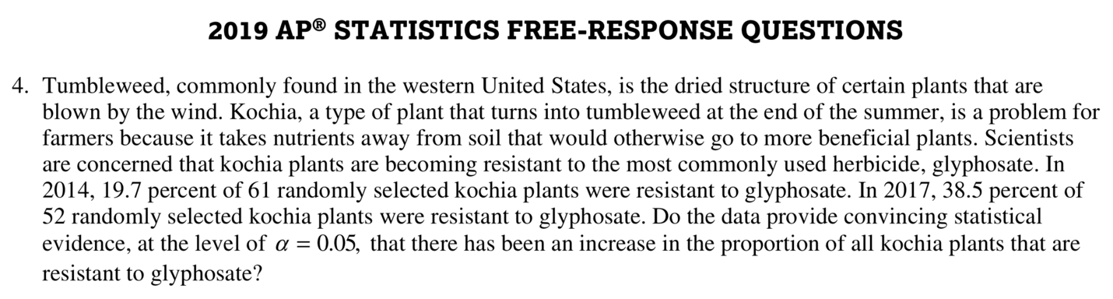

STATE: State the hypotheses you want to test and the significance level, and define any parameters you use.

Parameter: Statistic:

Hypotheses: Significance level:

PLAN: Identify the appropriate inference method and check conditions.

Name of procedure:

Check conditions:

DO: If the conditions are met, perform the calculations.

Picture:

General Formula: Test statistic:

Specific Formula: P-value:

Work:

CONCLUDE: Make a conclusion about the hypotheses in the context of the problem.

Conclusion:

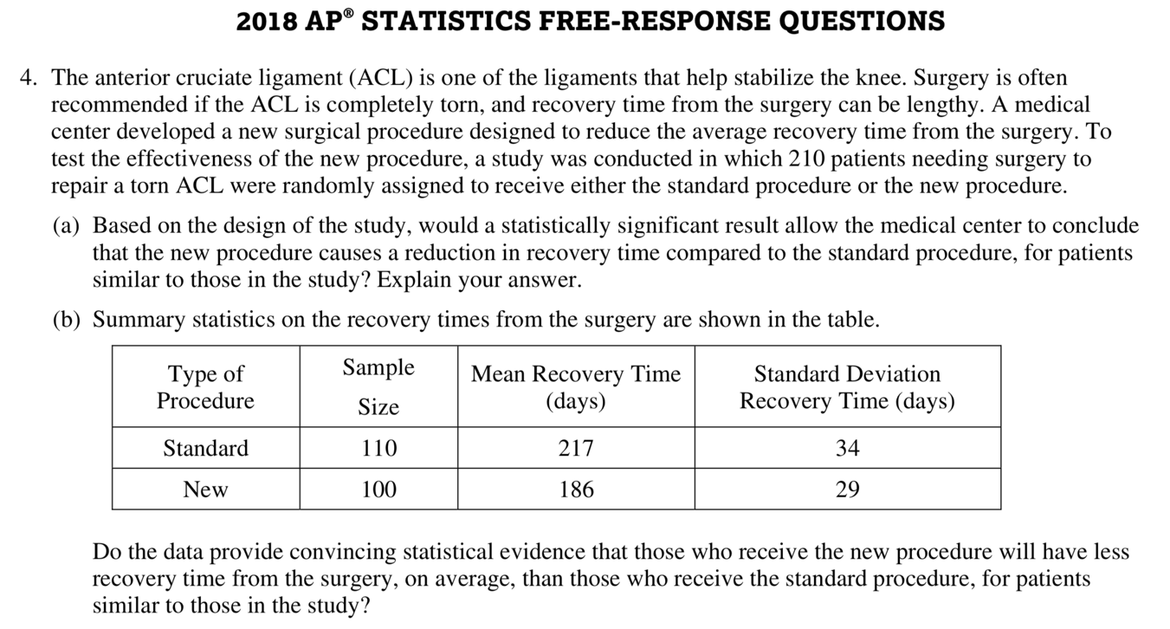

STATE: State the hypotheses you want to test and the significance level, and define any parameters you use.

Parameter: Statistic:

Hypotheses: Significance level:

PLAN: Identify the appropriate inference method and check conditions.

Name of procedure:

Check conditions:

DO: If the conditions are met, perform the calculations.

Picture:

General Formula: Test statistic:

Specific Formula: P-value:

Work:

CONCLUDE: Make a conclusion about the hypotheses in the context of the problem.

Conclusion:

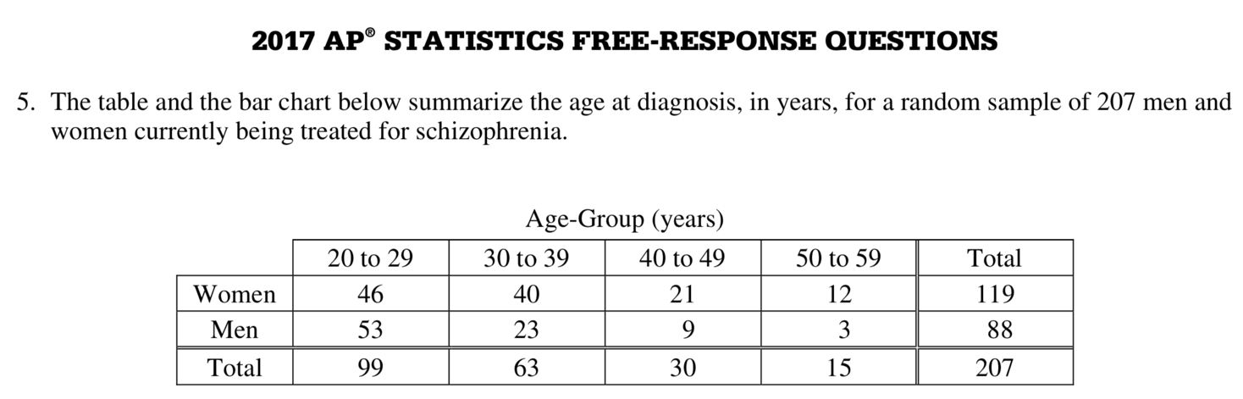

STATE: State the hypotheses you want to test and the significance level, and define any parameters you use.

Parameter: Statistic:

Hypotheses: Significance level:

PLAN: Identify the appropriate inference method and check conditions.

Name of procedure:

Check conditions:

DO: If the conditions are met, perform the calculations.

Picture:

General Formula: Test statistic:

Specific Formula: P-value:

Work:

CONCLUDE: Make a conclusion about the hypotheses in the context of the problem.

Conclusion:

2005 AP STATISTICS FREE RESPONSE QUESTIONS
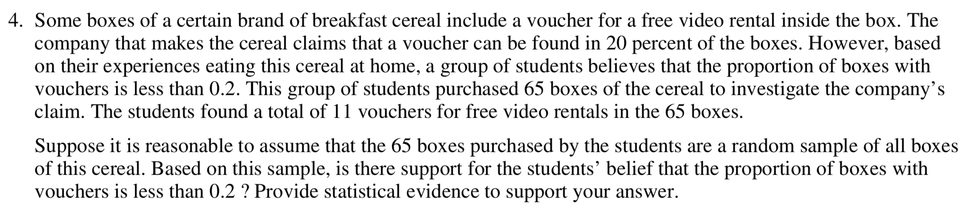

STATE: State the hypotheses you want to test and the significance level, and define any parameters you use.

Parameter: Statistic:

Hypotheses: Significance level:

PLAN: Identify the appropriate inference method and check conditions.

Name of procedure:

Check conditions:

DO: If the conditions are met, perform the calculations.

Picture:

General Formula: Test statistic:

Specific Formula: P-value:

Work:

CONCLUDE: Make a conclusion about the hypotheses in the context of the problem.

Conclusion:

