The Quadratic Function
Today we will be investigating what happens when we change the equation of the absolute value function, y = x². Go to Desmos.com and complete the questions below with your partner.
The Parent Function:

- The parent function for the family of absolute value functions is y = x².
Graph the function on the grid to the right.

- The vertex is located at .

- The axis of symmetry is at .

Graphing functions of the form $y=a{(x-h)}^{2}+k$.

- Use your knowledge of this function form to graph each of the following functions without Desmos. When you are done, check your graphs in Desmos and describe how the graph has transformed from the parent function.

- y = (x – 1)² b. y = x² – 4 y = 2(x – 1)² - 4

Vertex: Vertex: Vertex:

Axis of Symmetry: Axis of Symmetry: Axis of Symmetry:

Transformation: Transformation: Transformation:

- How could you find the vertex of the function without graphing the function?

- What do a, h and k do in this form?

Graphing functions of the form $y=a(x-p)(x-q)$.

- What do you think the graph of the function
y = 2(x + 3)(x + 2) will look like? Sketch it on the plane.

Now use Desmos to graph the function on the same plane. Sketch it in a different color.

- Graph each of the following functions using Desmos and find its vertex.

- y = (x + 1)(x – 3) b. y = – (x – 1)(x + 2) c. y = 2(x – 1)(x – 3)

Vertex: Vertex: Vertex:

Axis of Symmetry: Axis of Symmetry: Axis of Symmetry:

Transformation: Transformation: Transformation:

- How could you find the vertex of the function without graphing the function?

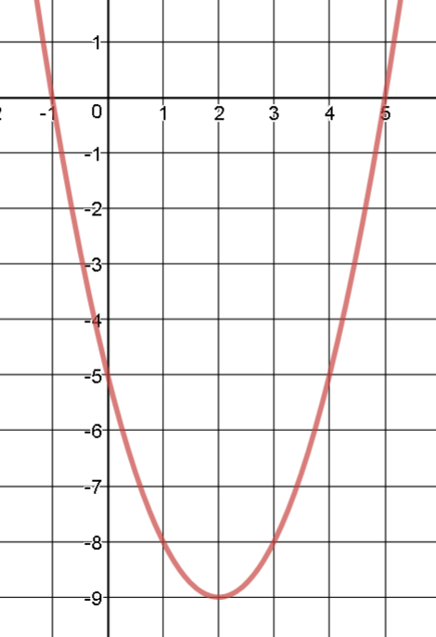
- What do a, p and q do in this form?

- Write an equation for the graph at right. Use whichever form you like.

Why did you choose the form you did? Why?

