Odds or evens, who will win?
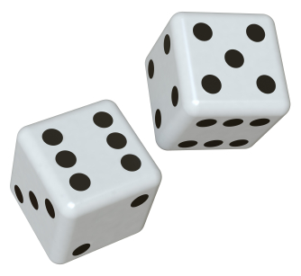

We’re going to play a game to answer this question. You and your partner must decide who will be “Odds” and who will be “Evens”. Then you will roll two dice and multiply the numbers. If the product is odd, the odds person wins and vice versa for evens. Play 20 times, keeping track of how many wins each person has.

- How many times did the odds win?

Write this as a fraction out of 20 and turn it to a percentage.

Maybe the odds just had a run of bad luck. Let’s see how the rest of the class did with odds. Write the number of odds wins for your group in the table on the board.

- Find the total percent of rolls that were odd products for the whole class.

How does this compare to your group’s results?

 | 1 | 2 | 3 | 4 | 5 | 6
1
2
3
4
5
6
- To determine the true probability of rolling an odd product, we should list out all possible products that we could get. Complete the table below to show all possible products (multiply).

- Use your table to find the probability of rolling an odd product.

- Which was closer to the percentage you found in #4, your group data or the classroom data? Why do you think that is?

- Use the table to find the probability of rolling each of the following products:

- 4 or a 5 b) Number besides 6 c) Number between 1 and 36

