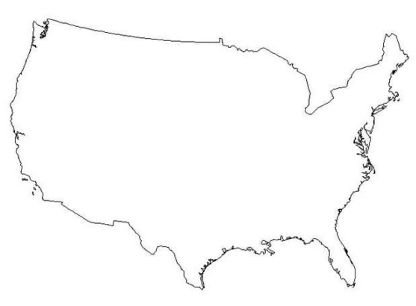**How many states can you name?**



How many states can you name in one minute? We will use this class as a random sample of all AP Stats students to estimate a 95% confidence interval for the mean number of states an AP Stats student can name in one minute.

1. When the timer starts, list as many states as you can on a piece of paper. Write the number of states you listed on the board.

2. What type of data is this? Categorical or quantitative?

2. Enter the class data at stapplet.com. Find the sample mean and standard deviation. Sketch the dotplot of the sample data.

 

3. Construct a 95% confidence interval to estimate the mean # of states a senior can name.

**STATE: State the parameter you want to estimate and the confidence level.**

Parameter: _____________________________________ Confidence level: _____

**PLAN: Identify the appropriate inference method and check conditions.**

Name of procedure:

Check conditions:

**DO: If the conditions are met, perform the calculations.**

General Formula for any confidence interval:

Specific Formula for this confidence interval:

Plug numbers into the formula:

Answer:

**CONCLUDE: Interpret your interval in the context of the problem.**

Interpret:

The Four Step Process

Important ideas:

Check Your Understanding

City council members want to estimate how many pounds of trash households in their community produce per week. To determine an estimate for the standard deviation of the weight of trash produced a small random sample of households was selected and their trash was weighed on garbage day. This produced an estimated standard deviation of 36 pounds.

1. How many households need to be surveyed to estimate *µ* at the 95% confidence level with a margin of error of at most 3 pounds?
2. After solving part (a), the city council realizes that it would be too much work to weigh the garbage of that many households. They give up on their hopes of estimating the true mean weight of trash produced within 3 pounds and select a random sample of 15 households and weigh the trash for each of these households on garbage day. Here are the results:

|  |  |  |  |  |  |  |  |  |  |  |  |  |  |  |
| --- | --- | --- | --- | --- | --- | --- | --- | --- | --- | --- | --- | --- | --- | --- |
| 114.8 | 74.3 | 80.1 | 41.5 | 99.1 | 31.0 | 93.1 | 118.9 | 26.5 | 33.1 | 88.3 | 46.1 | 119.7 | 46.4 | 19.8 |

Calculate and interpret a 95% confidence interval for the mean weight of trash for all households in this community.