Is Mrs. Gallas a good free throw shooter?
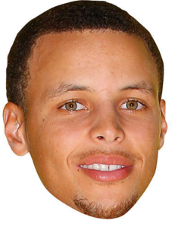

Mrs. Gallas claims she is an 80% free throw shooter. To prove her skills she shoots 50 free throws and makes 32 shots. Is Mrs. Gallas exaggerating about her free throw skills?

1. Identify the population, parameter, sample and statistic.

Population: Parameter:

Sample: Statistic:

2. There are two possible explanations for why Mrs. Gallas only made 32/50 shots.

1.)

2.)

To test Mrs. Gallas’ claim, we will assume #1, she is an 80% free throw shooter, and examine the likelihood that she makes 32/50 shots through simulation.

3. Use the spinner provided to simulate 50 free throws shot by an 80% free throw shooter by spinning 50 times. What is your sample proportion of shots made?

4. Repeat for another sample of 50 spins. Calculate the sample proportion.

5. Add your sample proportions to the dotplot on the board. Each person in your group should add two dots to the board. Sketch the dotplot below.

proportion of FT made

6. What does each dot represent?

7. One student says, “Each dot represents the proportion of free throws made out of 50 free throws shot by Mrs. Gallas.” Is this correct? Explain.

8. What percentage of the dots represent a percentage of 64% or less?

Interpret this percentage in context.

9. Based on your answer to Question 8, does the observed = 0.64 result give convincing evidence that Mrs. Gallas is exaggerating? Or is it plausible that an 80% shooter can have a performance this poor by chance alone?

