Are Soda Contests True?
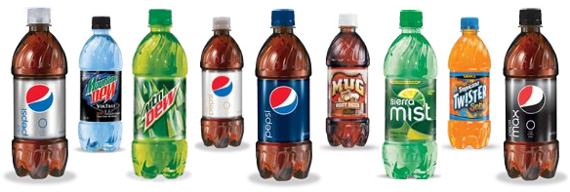

Pepsi ran a promo contest for their 20 oz. bottles of soda. Some of the caps said, “Please try again!” while others said, “You’re a winner!” Pepsi advertised the promotion with the slogan “1 in 6 wins a prize.” Mrs. Gallas’ statistics class wonders if the company’s claim is true. To find out, all 30 students in the class go to the store, and each buys one 20-ounce bottle of the soda. Two of the 30 students get caps that say “You’re a winner!”

- How many winners would you expect to get out of a class of 30? Is it guaranteed?

Does this result give convincing evidence that the company’s 1-in-6 claim is inaccurate? We will perform a simulation to help answer this question. We will assume Pepsi is telling the truth. If they are telling the truth, what is the probability of getting 2 or fewer winners in a class of 30 purely by chance? Let’s find out.

- What could we use to model a 1/6 probability? Assign certain outcomes to “Losers” and “Winners”. List them below.

- Roll your die 30 times to imitate the process of the students in Mrs. Gallas’ statistics class buying their sodas. How many of them won a prize?

- Repeat steps 1 and 2. How many won a prize this time?

- Plot the number of prize winners for each trial of 30 to the dot plot on the board. (2 dots)

- Sketch the class dot plot below.

- What percent of the time did Mrs. Gallas’ statistics class get two or fewer prizes, just by chance?

- Does it seem plausible that the company is telling the truth but that the class just got unlucky? Or do we have convincing evidence that Pepsi is lying?
Simulation
Important ideas:

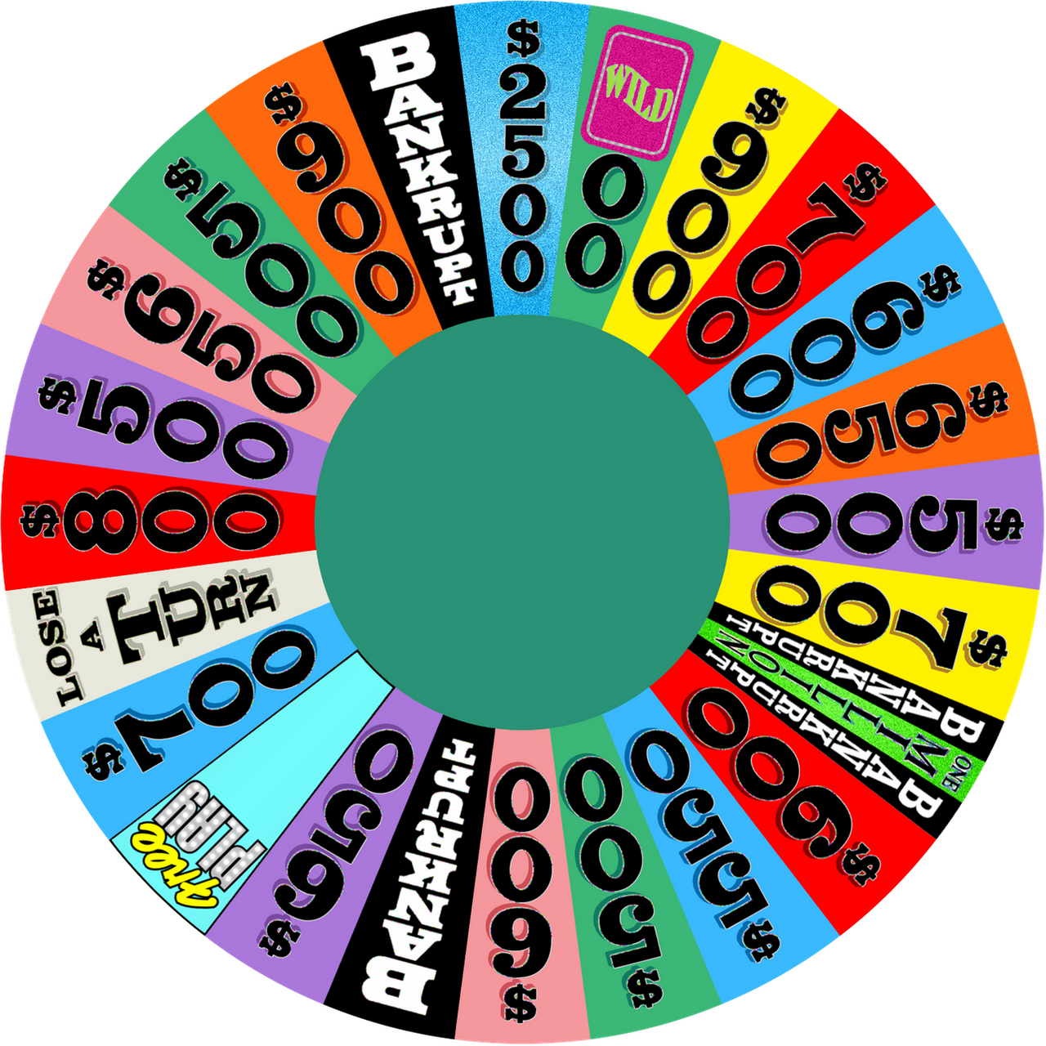
Check Your Understanding
Some people have wondered if the Wheel of Fortune wheel is fair. If it is fair, the “Bankrupt” result should occur with probability 1/9. To test the wheel, Pat Sajak observed a random sample of 50 spins of the wheel and found that “Bankrupt” was spun 10 times. Is this convincing evidence that Bankrupt comes up more often than it should?

- Describe how you would carry out a simulation to estimate the probability that in a fair wheel, Bankrupt comes up 10 or more times.

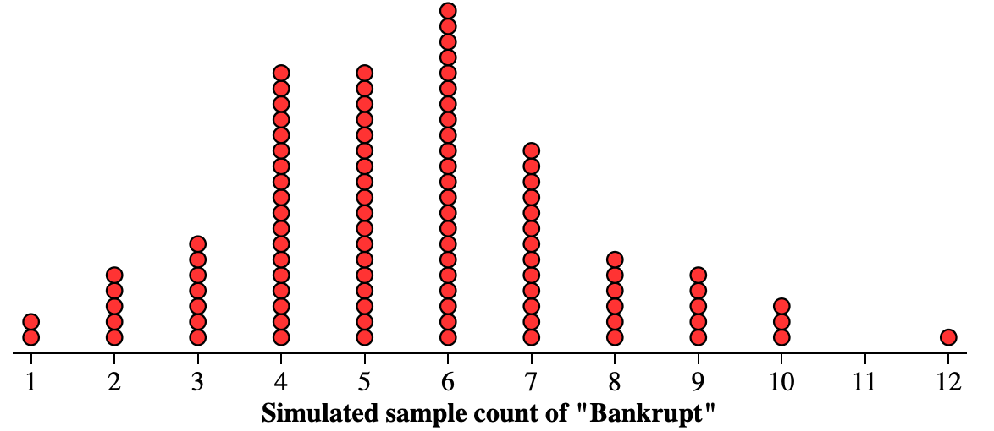
The dotplot displays the results of 100
simulated trials of 50 spins of a fair wheel.

- Explain what the one dot above 12 indicates.

- What conclusion would you draw about 10 or more Bankrupt spins occurring in 50 spins? Explain your answer.

