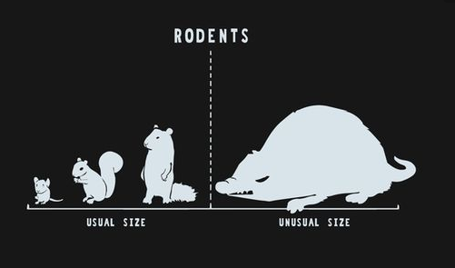 **How tall are we?**



How tall are high school seniors in Michigan? Attached are the heights of all 50 high school seniors at a small high school in the upper peninsula.

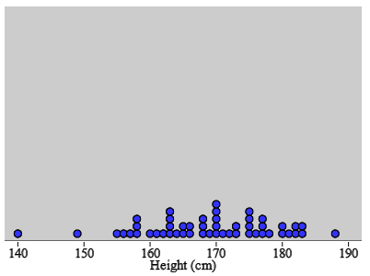

1. Make a guess at the mean of all 50 students. Make another guess of the standard deviation of all 50 students.
2. Select a random sample of 5 students and calculate the mean height for the sample. Repeat for 4 samples total.

Heights: $\overline{x}=$

__________________________ ___________

Heights: $\overline{x}=$

__________________________ ___________

Heights: $\overline{x}=$

__________________________ ___________

Heights: $\overline{x}=$

__________________________ ___________

1. Add your sample means to the dotplot on the board. Sketch it below.



1. Describe the shape, center, and variability of this dotplot.
2. Compare the two dotplots above. How are the dotplots similar? How are they different?

Sample Means

Important ideas:

Check Your Understanding

Every day people watch 1 billion hours of videos on YouTube. That breaks down to every single person on earth watching YouTube videos for about 8.4 minutes per day. For U.S. teens, in any given day, the amount of time spent watching YouTube videos is approximately Normal with mean 18.5 minutes and standard deviation 5.3 minutes.

a. Find the probability that a randomly chosen U.S. teen watches YouTube for more than 25 minutes in a given day.

Suppose we choose an SRS of 10 U.S. teens. Let = the mean amount of time spent watching YouTube videos for the sample.

1. What is the mean of the sampling distribution of ?
2. Calculate and interpret the standard deviation of the sampling distribution of . Verify that the 10% condition is met.
3. Find the probability that the mean amount of time spent watching YouTube for the teens in the sample exceeds 25 minutes.