How does GPA relate to ACT score?

Mrs. Gallas is wondering if there is a relationship between GPA and ACT score. She took a random sample of 9 out of her 101 students and recorded their GPA and ACT score. The data are below.

Student # | 83 | 69 | 96 | 89 | 57 | 13 | 24 | 37 | 91
GPA | 3.7 | 2.3 | 4.0 | 3.8 | 3.0 | 1.8 | 2.0 | 2.3 | 3.9
ACT | 23 | 20 | 35 | 33 | 22 | 13 | 17 | 20 | 29

- What relationship would you expect GPA and ACT score to have? Explain.

Here is the Minitab ouput as well as graphs of the data.
Predictor Coef SE Coef T P
Constant 1.201 0.0874 13.72 0
GPA 7.507 1.29 5.82 0.0006511
S = 3.252686 R-Sq = 82.8% R-Sq(adj) = 76.5%

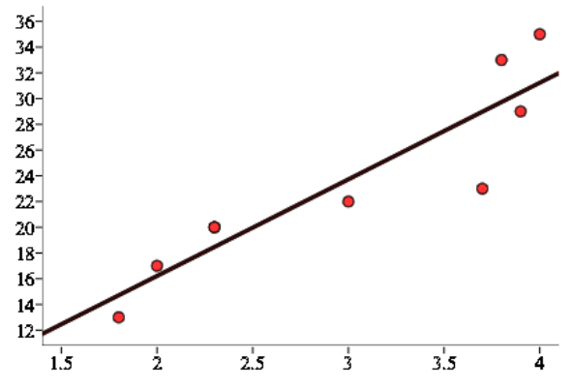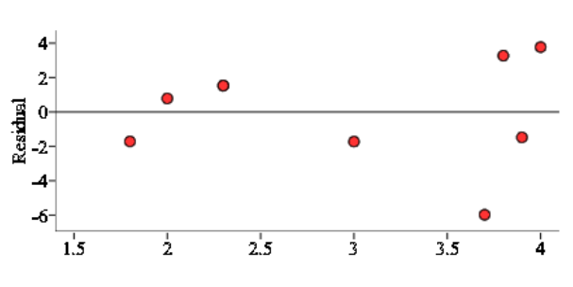
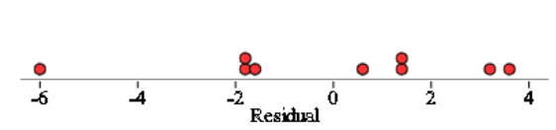
- Find the LSRL for the data.

- Do the data provide significant evidence that there is a positive linear relationship between GPA and ACT?
STATE:
Parameter: Statistic:

H₀:

H_{a}: Sign. Level:

PLAN: Name of procedure:

Check conditions:

- Linear: (2) Independent:

- Normal: (4) Equal SD:

- Random:

DO: General Formula:

Specific Formula: Picture:

Work:
Test statistic:

P-value:

CONCLUDE:

Significance Test for Slope
Important ideas:

Check Your Understanding
You may have heard that your nose and ears grow through your whole life. While it is true that your nose and ears get bigger throughout life, it’s not because they grow, but because of gravity. The cartilage in your nose and ears break down as we age and the “growth” people observe is the result of drooping. To quantify the expansion of ears over time, a random sample of 30 adults were selected. For each adult, their age (in years) was recorded and their ear height (cm) was measured. Below is the regression output. Is there convincing evidence of a positive linear relationship between age and ear height? Assume the conditions for inference are met.

