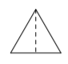
Discovering Special Triangles
Today, you will be using what you know about triangles to look for patterns in special triangles. With a partner cut out the triangles you’ve been given and complete the questions below.

- What type of triangles are they? How do you know?

- Take the largest triangle label all the side lengths and angle measures.

Side lengths: Angle measures:

- Fold the triangle in half, and cut along the fold. You now have two congruent triangles, one for you and one for your partner. What are the measures of each of the angles? Label them on your triangle.

Smallest angle: Middle angle: Largest angle:

- What is the length of each of the sides? List them in exact values below, and label them on your triangle.

Smallest side: Middle side: Largest side:

- Repeat this process for the remaining two triangles. Fill in the tables below.

 | Smallest angle | Shortest side | Middle angle | Middle side | Largest angle | Largest side
Smallest right triangle
Middle right triangle
Largest right triangle

- Do you notice any patterns? Describe them below.

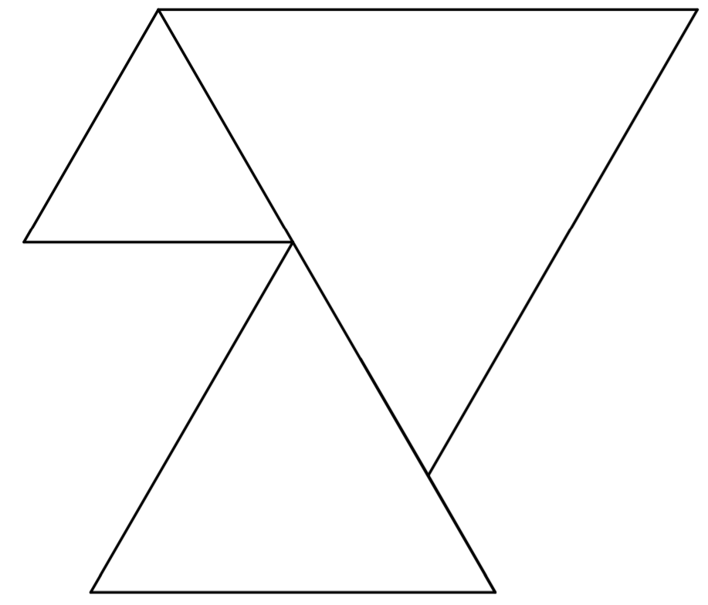
6
4
8

