How safe is Barbie?
How can we be sure that the bungee cord we make Barbie will keep her safe? Should you be worried if you used the wrong units, chose the wrong axes, or measured wrong?

Below is the data for one group’s Barbie bungee.
Number of rubber bands | 0 | 1 | 2 | 3 | 4 | 5 | 6 | 7
Distance traveled (in) | 12 | 14 | 17 | 18 | 22 | 23 | 26 | 30

- Go to stapplet.com and create a scatterplot. Sketch it to the right. (Leave extra room on the right.)

- Find the correlation. r = ______

- How safe do you feel Barbie’s bungee jump would be if we use this data? Use the correlation to justify.

- One of the group members snuck some extra rubber bands to collect more data. Add the point (15 rubber bands, 49 in) to your scatterplot. How do you think this outlier will affect the correlation? Verify in the applet. What is the new r?

- One group member accidently left off a digit. Add the point (6 rubber bands, 6 in) to the scatterplot. How do you think this outlier will affect the correlation? Verify in the applet. What is the new r?

Unfortunately, the group had measured the lowest point of Barbie’s head in inches instead of centimeters. To fix this they multiplied the inches by 2.54 (1 in. = 2.54 cm). The new data is below.

Number of rubber bands | 0 | 1 | 2 | 3 | 4 | 5 | 6 | 7
Distance traveled (cm) | 30.48 | 35.56 | 43.18 | 45.72 | 55.88 | 58.42 | 66.04 | 76.20

- How do you think these changes will affect the correlation? Verify by calculating the correlation in the applet.
Displaying Relationships: Correlation
Important Ideas:

Check Your Understanding:

Fueleconomy.gov gives the city and highway fuel economy for all makes and models of vehicles back to 1984. The scatterplot displays the city and highway fuel economy (mpg) for a random sample of ten 2021 vehicles.

City fuel economy (mpg) | 14.4 | 24.3 | 27.2 | 29.9 | 20.4 | 28.8 | 20.9 | 23.2 | 28.6 | 25.4
Highway fuel economy (mpg) | 25.5 | 37.4 | 36.5 | 45.5 | 28.7 | 46.1 | 33.6 | 38.3 | 41.3 | 35.3

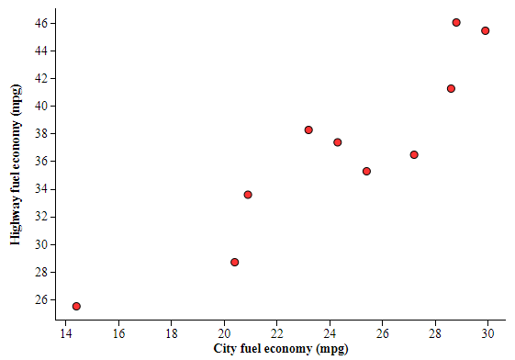
- The correlation between city fuel economy and highway fuel economy for these 10 vehicles is r = 0.917. Interpret this value.

- If fuel economy was measured in feet per gallon, rather than miles per gallon how would the value of the correlation be affected? Explain.

- The Rolls-Royce Ghost EWB gets 14.4 city mpg and 25.5 highway mpg. What affect does this point have on the correlation? Explain.

