Can we predict a person’s height from their shoe?

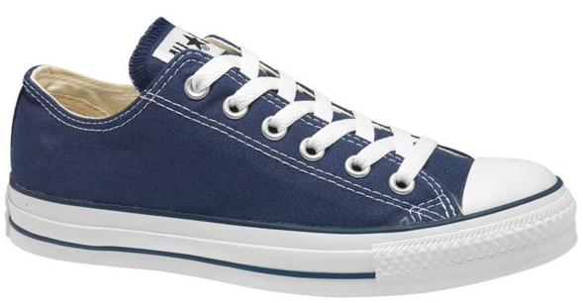
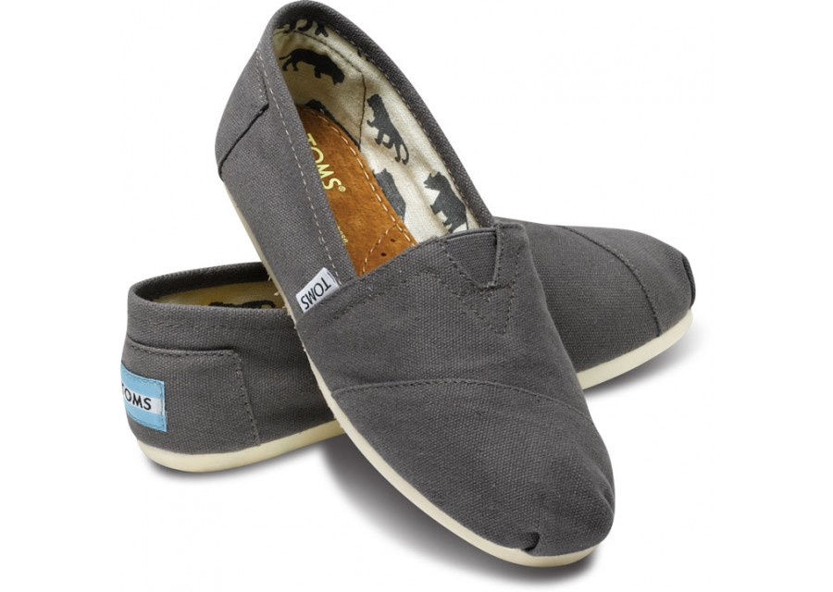

Could we use the length of a person’s shoe to accurately predict their height? We will start by collecting some data.

What is the length of your shoe (cm)?________ What is your height (cm)? _________

Record these values somewhere in the classroom and then record class data here:

Shoe (cm)
Height (cm)

Shoe (cm)
Height (cm)

- Which variable is the explanatory?____________________

Which variable is the response?____________________

- Make a scatterplot of the class data.
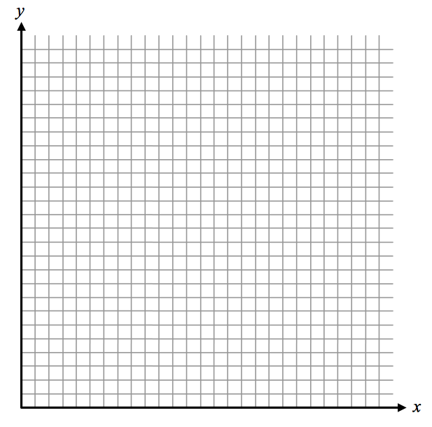

3. Describe the relationship
displayed in the scatterplot.

