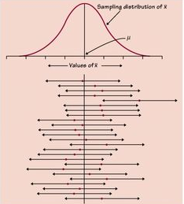
What does “95% confident” mean?

In this Activity, you will use the applet at www.tinyurl.com/appletCI to learn what it means to say we are “95% confident” that our confidence interval captures the true proportion.

- Use the Confidence Intervals for Proportions applet. Set the population proportion to 0.5, the confidence level to 95% and the sample size to 75.

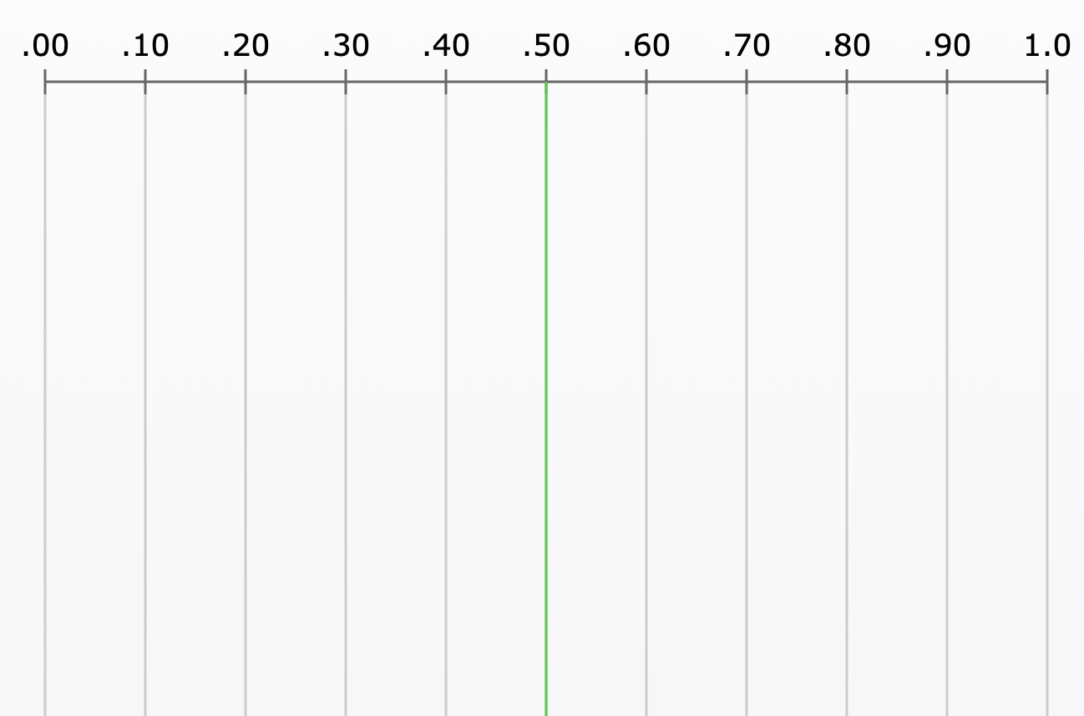
- Click “Sample” to choose an SRS and display the resulting confidence interval. The confidence interval is displayed as a horizontal line segment with a dot representing the sample proportion in the middle of the interval. The true proportion (p) is the green vertical line.

Did the first confidence interval capture the true proportion?

Repeat this 10 times and sketch what you see to the right. How many of the intervals capture the true proportion?

- “Reset” and then take a total of 100 confidence intervals (sample 25 four times). How many out of 100 captured the true proportion? Is this surprising? Why?

- Watch your confidence intervals as you drag the confidence level from 95% to 99% (don’t “Reset). What happens to the intervals when the confidence level is increased? Why does this make sense?

- “Reset”, then sample 100 times at an 80% confidence interval. What percent of the intervals capture the true proportion?

Interpret the confidence level:

- Now we will see what happens when we adjust the sample size. Change the sample to 20 and sample for 1 interval. Then change it to 250 and sample for 1 interval. What happens to the interval when the sample size is increased? Why?

Interpreting the Confidence Level
Important ideas:

Check Your Understanding
The gym teacher of a large high school wants to estimate the mean number of pushups students at this school can do in one minute. He selects a random sample of 30 students from those who are there after school for sports practices. He records how many pushups each of the students in the sample can do in one minute. He determines that he is 90% confident that the interval from 24.1 to 28.5 captures the mean number of pushups that students at this school can do in one minute.

- Interpret the confidence level.

- Explain what would happen to the length of the interval if the confidence level were increased to 99%.

- How would a 90% confidence interval based on a sample of size 200 compare to the original 90% interval?

- Describe one potential source of bias in this study that is not accounted for by the margin of error.

