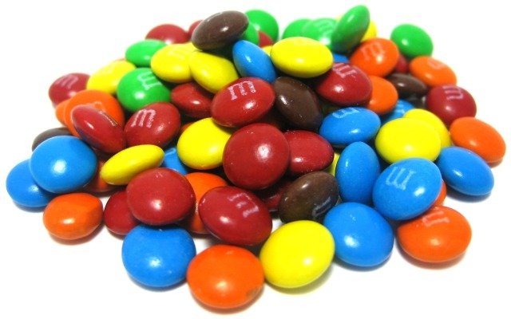 **Which color M&M is the most common part two?**

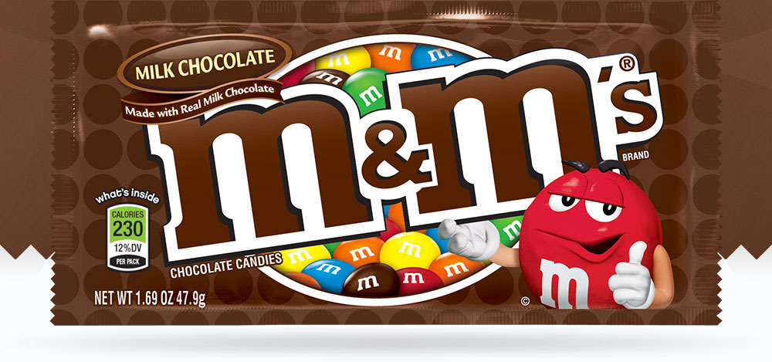

The company that makes milk chocolate M&Ms claims the following distribution:

13% Brown, 14% Yellow, 20% Orange, 16% Green, 24% Blue, and 13% Red. Is this true?

**1. Record the information from yesterday.**

Observed values: Brown:_____ Yellow:_____ Orange:_____ Green:_____ Blue:_____ Red:_____

Expected values: Brown:_____ Yellow:_____ Orange:_____ Green:_____ Blue:_____ Red:_____

Test statistic: = _________

**2. Check conditions:**

Random:

10%:

Large counts: Which expected count is the lowest? Are all of the expected counts greater than 5?

**3. Calculate the P-value.**

For this test *df* = *n* – 1, but n represents the number of categories (colors).

What is the *df* for this test?_______

What is the test statistic for this test?________

Use Table C to find the P-value:________

**4. Make a conclusion.** Use .

5. Which color M&M had an observed value the farthest from the expected?

Do the data provide significant evidence that the company was lying about the distribution of colors of M&Ms? Use 

**STATE:**  Hypotheses: Significance level:

**PLAN:**  Name of procedure: chi-square test for goodness of fit

Check conditions:

**DO:** Picture:

Specific Formula:

Work:

Test statistic:

P-value:

**CONCLUDE**:

What parts of the usual 4-step process are missing in this test?

Chi-Square Test for Goodness of Fit: 4 Steps

Important ideas:

Check Your Understanding

A traffic light is installed to allow traffic from a seldom used side street to cross a 4-lane highway. Because the side street doesn’t get a lot of traffic the light is set to provide a red light for the side street 80% of the time, yellow 5% of the time, and green 15% of the time. A resident who must pass through the light several times per day is suspicious that the light is not functioning according to the claimed distribution. He sets up a trail camera and programs it to snap a picture of the light at 200 randomly selected times throughout the day. Here are the results: Red: 173, Yellow: 13, and Green: 14.

1. Do these data provide convincing evidence that the light is not functioning according to the claimed distribution?

**STATE:**  Hypotheses: Significance level:

**PLAN:**  Name of procedure:

Check conditions:

**DO:**  Specific Formula: Picture:

Work:

Test statistic:

*P*-value:

**CONCLUDE:**

1. If there is convincing evidence of a difference in the distribution of car color, perform a follow-up analysis.